Registration Information
Each seminar is limited to 100 participants only who must register ahead of time. AIFEE will take care of the costs for lunch and tea during the conference. Participants are responsible for their own travel and accommodations.

To register, please contact:
Mrs. Jacinta Kimunyu
District Staffing Officer /Conference Coordinator
+254 725-271776
Or your local education office
For more information on the upcoming conference, please email AIFEE at Africaninternationalfoundation@gmail.com.
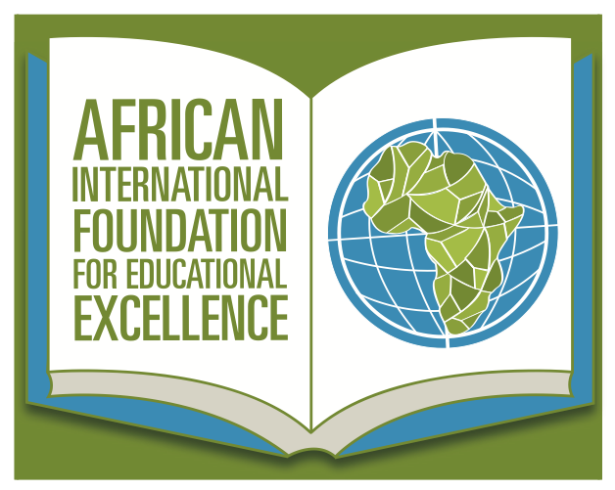

African International Foundation for Educational Excellence
P.O Box 3072
Carbondale, IL 62902
United States of America
+1 563-580-4980
www.Africaninternationalfoundation.org

Achieving Educational Excellence Seminars

Theme: Closing the Achievement Gap through Effective Educational Interventions

Sponsored by the African International Foundation for Educational Excellence (AIFEE), the District Education Office and Northern Kentucky University (USA)

May 26-30, 2014
Karatina and Muranga
Kenya
This series of one day seminars builds on the January Conference by engaging educational stakeholders in developing strategies to lift academic standards for students in rural primary schools in order to establish a competitive edge with their peers in other settings. Invited participants include building school administrators, teachers, government education officers and community leaders. Participants should come prepared to engage with conference presenters on proven and comprehensive strategies to build effective administrative and management systems, identifying and implementing timely interventions with students and motivating students to succeed. In addition, the seminars will serve as a forum to conduct a needs assessment that will inform future professional development activities spearheaded by the sponsors.

Conference Facilitators


Dr. Peter Gitau is the Founder, President, and Chief Executive Officer of the African International Foundation for Educational Excellence (AIFEE). Previously, he was Co- Founder and Executive Director of Teach My Kenyan Children (TMKC). Dr. Gitau is also the Vice President for Student Affairs at Northern Kentucky University in the United States. He is a proven leader with many years of executive leadership and management experience both nationally and internationally.

Brandelyn Tosolt, Assistant Professor, Teacher Education, is a graduate of Michigan State University (BA, 2000), University of Michigan (MAT, 2003), and Oakland University (PhD, 2008). She taught middle grades in both private and public schools in Detroit, Michigan. Since arriving at NKU, she has taught undergraduates, both alternative certification and traditional students at the master’s level, and doctoral students. Engagement, both with course material and with and among learners, is central in her courses. Her research privileges the voices of historically-underrepresented groups and seeks to understand perspectives on events in individual lives and the broader society. Her research has been published in a variety of peer-reviewed journals, including The Journal of Negro Education; Multicultural Perspectives; Race, Gender & Class; and International Journal of Multicultural Education.

Lenore Kinne earned a Ph.D. in Educational Psychology with a concentration in Learning & Cognition from the University of Minnesota. At Northern Kentucky University, she teaches courses in classroom assessment, learning/motivation, and educational research. Prior to teaching at the university level, she was a teacher of elementary-aged children.

Leah Hetzell is a Student Affairs professional in the field of higher education. She serves as a Resident Director at Temple University in Philadelphia, Pennsylvania where she oversees a building of 500 first-year residential students and is responsible for managing and developing a staff of 13 undergraduate student leaders. Leah is currently pursuing her doctorate in Educational Leadership at Temple University and is working towards completion of her dissertation focused on transformation in the context of international service learning. Prior to her work at Temple University, Leah completed her B.A. in International Relations as well as a Masters in Public Administration (M.P.A.) at Clark University, where she also served as the director of safety service initiatives with the Campus Safety department for three years following graduation. Leah is passionate about the power of international education as well as the notion of global citizenship, and is greatly looking forward to traveling to Kenya this May and learning more about the Kenyan system of education.

About AIFEE
The African International Foundation for Educational Excellence (AIFEE) is a nonprofit organization committed to providing educational development in Africa. The strategic goals of the foundation fall under the following categories:
▪ Need Based Interventions
▪ Community Development
▪ Research and Assessment
▪ Education and Training
▪ Strategic Consultancy

