Registration Information
The conference is open to head-teachers and their deputies, teachers, members of the school board and other community leaders. Participants must register ahead of time by contacting Mrs. Jacinta Kimunyu. AIFEE and partners will take care of the costs for lunch and tea during the conference. Participants are responsible for their own travel and accommodations.
For inquiries, please contact:
Dr Peter Gitau, President of AIFEE
Africaninternationalfoundation@gmail.com
OR
Mrs. Jacinta Kimunyu, the Conference Coordinator
+254 725-271776
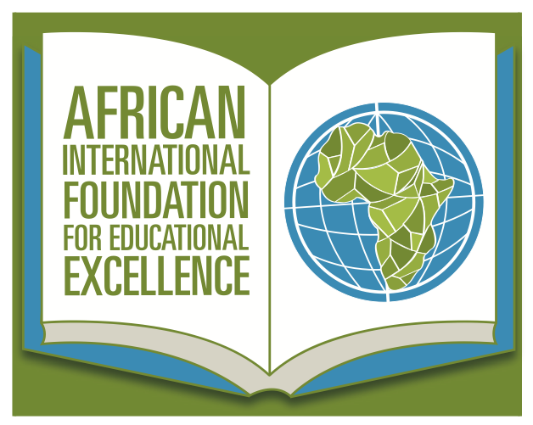

African International Foundation for Educational Excellence
2905 University Drive
Crestview Hills, KY 41017
United States of America
+1 859-907-7409
Email: Africaninternationalfoundation@gmail.com
www.Africaninternationalfoundation.org

7th Annual Achieving Educational Excellence Conference

Theme: Nurturing School Climates that Promote Student Success

Sponsored by the African International Foundation for Educational Excellence (AIFEE), USA.

July 11-12, 2019
Nyeri, Kenya
The purpose of this conference is to bring together relevant stakeholders to collaborate, brainstorm, and document strategies for nurturing school climates that promote student success. In addition to insightful and thought provoking plenary keynote sessions, participants will work in groups around the following key themes: 1) Managing student behavior 2) Promoting learner engagement and 3) Developing effective partnerships for student success. Participants will include educators, county and national government officials, parents, and students. Facilitators will be a team from the United States joined by local experts in education and governance. Working group facilitators will compile a report of actionable recommendations that will be shared with conference attendees and stakeholders and published for policy guidance.
Conference Facilitators

Dr. Peter Gitau is the Vice President for Student Affairs at Dixie State University in Utah, USA. He is also the Founder, President, and Chief Executive Officer of the African International Foundation for Educational Excellence (AIFEE). He holds a PhD in Higher Education Administration from the University of Kansas, a Master’s in Education Administration from Eastern Illinois University and a Bachelor’s in Secondary Education from Kenyatta University. A proven and seasoned higher education administrator and leader with many years of executive leadership and management experience, Dr. Gitau consults nationally and internationally on School Improvement, Diversity and Globalization, Strategic Planning, Capacity Building and Organizational Development.

Dr. Ted Grace is the Director of Student Health Services at Southern Illinois University, Carbondale. He earned his undergraduate and MD degrees from Ohio State University and his MPH degree from San Diego State University, where he also completed a Fellowship in Student Health Administration. He has previously served as the Medical Director of the Student Health Center at San Diego State University and Director of Student Health Services at Ohio State University. Dr. Grace is a Fellow of the American College of Physicians, American Academy of Family Practice, American College of Preventive Medicine, and American College Health Association (ACHA). Following his 6-year term as Executive Editor of the Journal of American College Health, he continues as the Journal’s photo-editor. He has been honored by ACHA with the E. Dean Lovett Award (2000) for exemplary contributions to a college health program, the Ollie B. Moten Award (2005) for outstanding service to one's institution, and the Clifford B. Reifler Award (2011) for outstanding contributions to the Journal of American College Health.
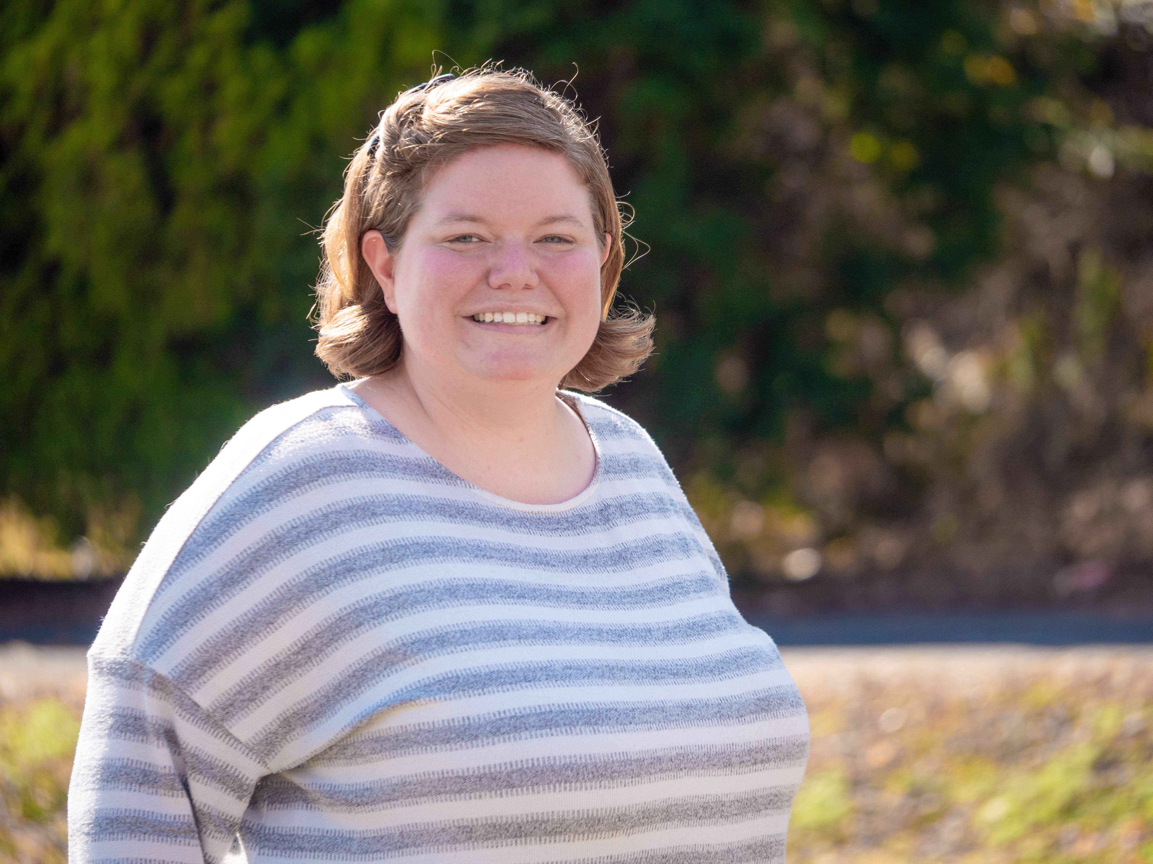
Susan Dalton holds a Bachelor of Arts in Bible and Interdisciplinary Studies from Johnson University, a Masters of Arts in Human Service Counseling with a specialization in Marriage and Family from Liberty University, and an Educational Specialist Degree in Educational Leadership with a specialization in Curriculum and Instruction from Carson-Newman University. She is currently finishing a Doctorate of Education in Educational Leadership from Carson-Newman University. She has facilitated the enrollment of students from over 40 different countries into local public schools and teaches English as a Second Language in k-12 classes. Susan volunteers as director of children’s ministry at Life Church, Knoxville, Tennessee and consults with a variety of non profit organizations.


Alissa Atwood is from Salt Lake City, Utah and is certified to teach in grades k-12. She graduated from Weber State University in 2016 with a bachelor degree in Elementary Education (K-6) and an emphasis in Spanish. Alissa has taught at inner city, catholic, public, and charter schools in Ogden, Utah and in the Bronx, New York. She intends to pursue a double master in elementary and special education.

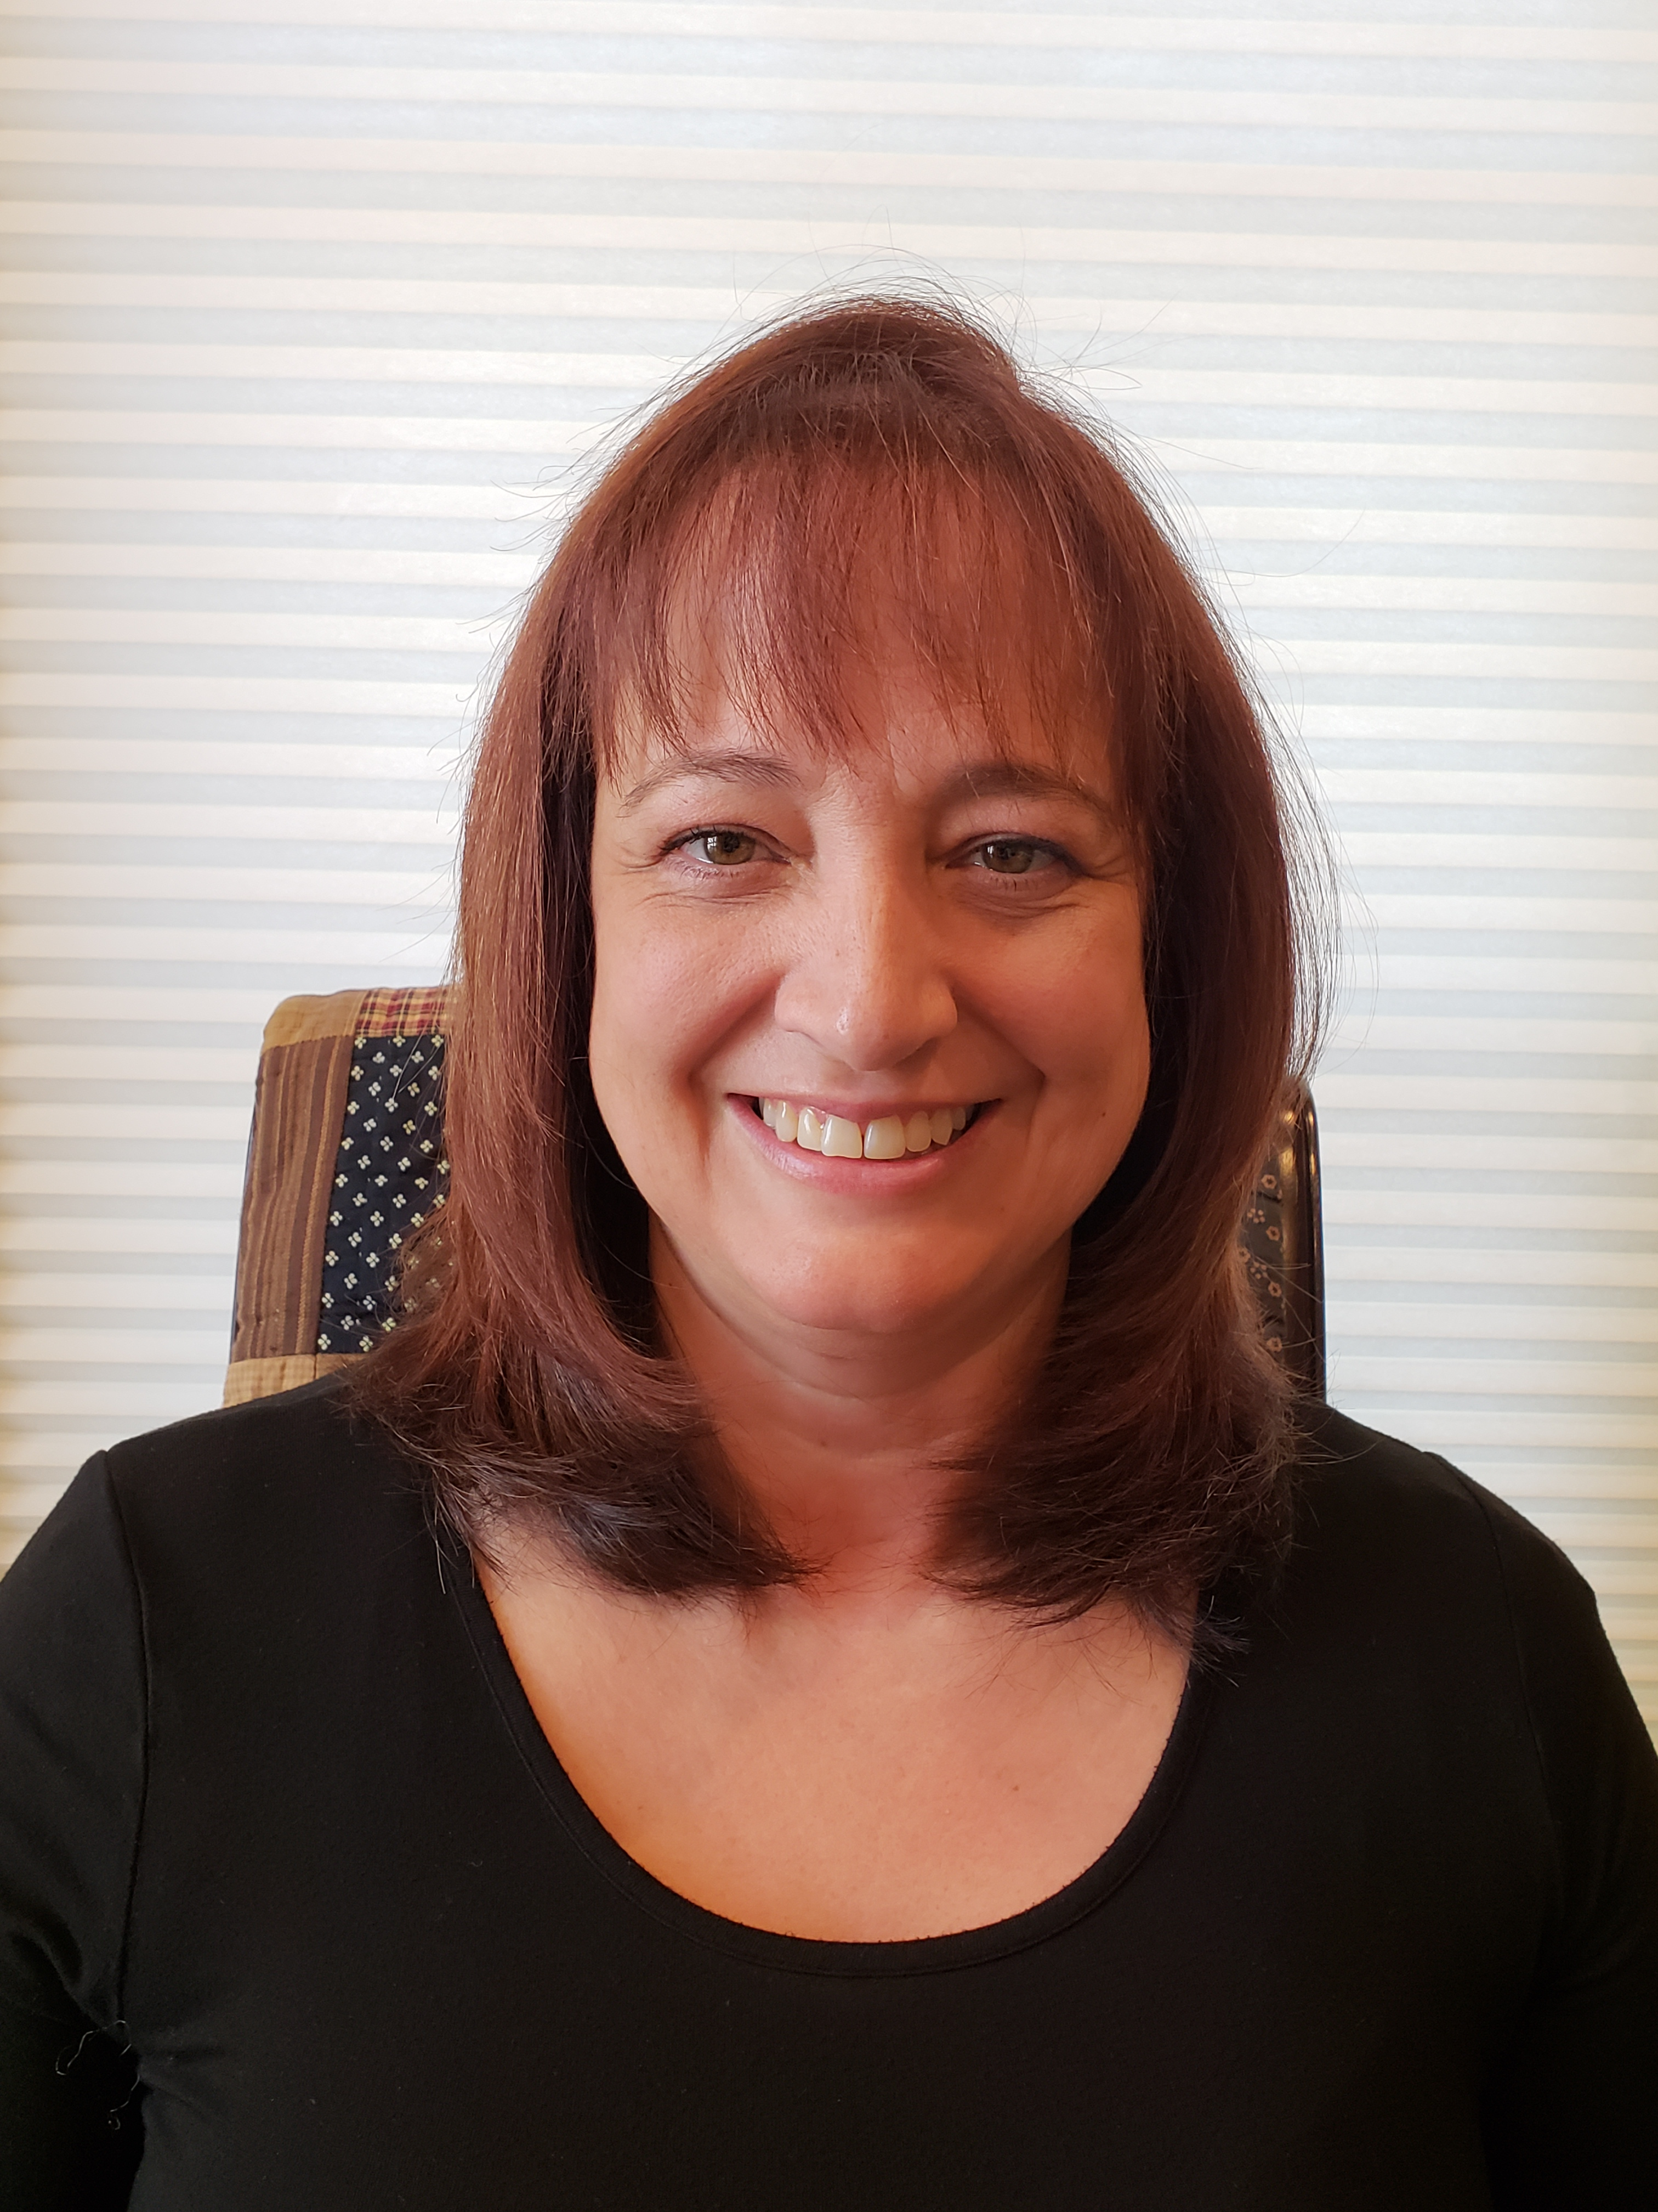
LaDawn Richey believes that God and family are the most important things in life. She is a mother of four, grandmother of one and has been married to her husband Mike for 30 years. She is passionate in helping others and loves giving others a chance to improve their circumstances. She understands that education is the key to achieving this. She has many years of experience in running, managing, organizing, and building businesses and has built a successful business with her husband Mike. She has experience and expertise in the retail, hospitality, health and travel industries and she is looking forward to fulfilling her lifelong dream of visiting Kenya this year.

About AIFEE
The African International Foundation for Educational Excellence (AIFEE) is a nonprofit organization committed to providing educational development in Africa. The strategic goals of the foundation fall under the following categories:
▪ Need Based Interventions
▪ Community Development
▪ Research and Assessment
▪ Education and Training
▪ Strategic Consultancy

